**Visual question Scratch**

1. Put a mark where the Script area is

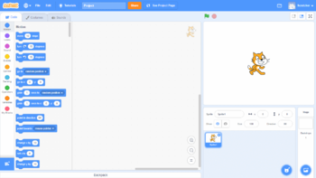

2. Please circle the move block



3. Put a mark where the new sprite button is



4. Please mark where the 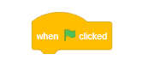is situated in the code blocks



5. Please circle the Say Hello for 2 sec block



6. Please circle the Forever block

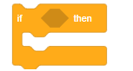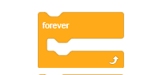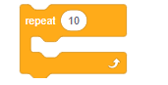

7. Please circle the pick random block



8. Please circle the Play sound until done blocks



9. Put a mark where the the green flag is



10. Please circle the touching block



11. Please circle the mascot for Scratch

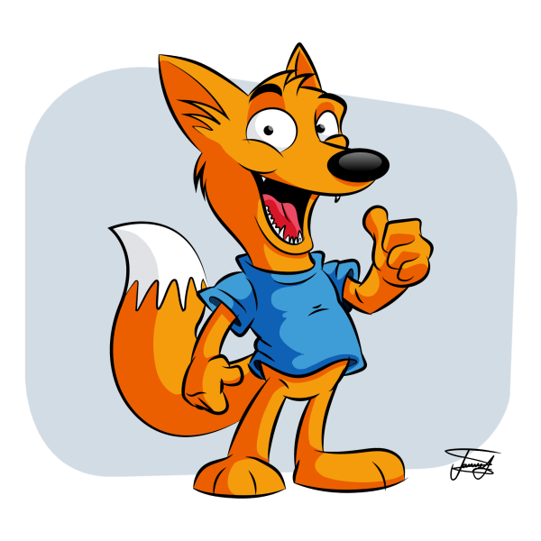  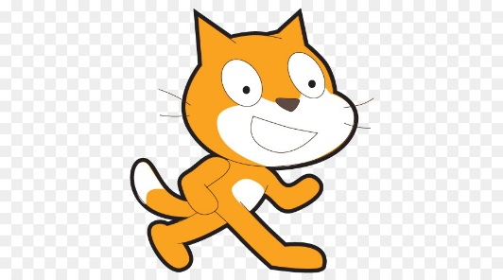

12 Put a mark on where you can go to add sound to your Scratch creation.

